Joel Atkinson
January 15, 2026
CSD-430 Server Side Development
Assignment 3.2

Code for JSP File:
<%--
Joel Atkinson, January 15,2026, CSD430 Server Side Development Assignment 3.2
The purpose of this assignment is to create a program that accepts different types of data with at least 5 data entry
points, then create a separate JSP file to display the data that is collected
--%>
<%@ page language="java" contentType="text/html; charset=UTF-8"
pageEncoding="UTF-8"%>
<!DOCTYPE html>
<html lang="en">
<head>
<meta charset="UTF-8">
<meta name="viewport" content="width=device-width, initial-scale=1.0">
<title>Thank You - Joel's Pizzeria</title>
<link rel="stylesheet" href="Assignment_3_2.css">
<style>
/* Additional styles just for the thank-you/display page */
header h1 {
font-size: 2.8rem;
padding: 25px 15px;
}
main {
max-width: 800px;
}
table {
width: 100%;
border-collapse: collapse;
margin-top: 25px;
background-color: #fff;
box-shadow: 0 3px 15px rgba(0,0,0,0.1);
}
th, td {
padding: 14px 18px;
text-align: left;
border-bottom: 1px solid #ddd;
}
th {
background-color: #c8102e;
color: white;
}
.thanks-msg {
text-align: center;
font-size: 1.4rem;
margin: 30px 0;
color: #006400;
}
</style>
</head>
<body>
<header>
<h1>Joel's Pizzeria</h1>
</header>
<div class="green-line"></div>
<main>
<h2>Mama Mia! That's a'lotta Feedback!</h2>
<p class="thanks-msg">Thank you!
<br>Joel's Pizzeria team</p>
<table>
<tr>
<th>Field</th>
<th>Your Response</th>
</tr>
<%
// Get all form parameters
String name = request.getParameter("name");
String email = request.getParameter("email");
String source = request.getParameter("source");
String ratingStr = request.getParameter("rating");
String experience = request.getParameter("experience");
// Handle null values safely
if (name == null) name = "N/A";
if (email == null) email = "N/A";
if (source == null) source = "N/A";
if (experience == null) {
experience = "N/A";
} else {
experience = experience.replace("\n", "<br>");
}
// Parse rating safely
int rating = 0;
try {
if (ratingStr != null && !ratingStr.trim().isEmpty()) {
rating = Integer.parseInt(ratingStr);
}
} catch (NumberFormatException e) {
rating = 0;
}
%>
<tr>
<td><strong>Name</strong></td>
<td><%= name %></td>
</tr>
<tr>
<td><strong>Email</strong></td>
<td><%= email %></td>
</tr>
<tr>
<td><strong>How did you hear about us?</strong></td>
<td><%= source %></td>
</tr>
<tr>
<td><strong>Rating</strong></td>
<td>
<%
if (rating >= 1 && rating <= 5) {
out.print("<span class='rating-stars'>");
for (int i = 0; i < rating; i++) {
out.print("&#9733;");
}
for (int i = rating; i < 5; i++) {
out.print("&#9734;");
}
out.print("</span> (" + rating + "/5)");
} else {
out.print("Not provided");
}
%>
</td>
</tr>
<tr>
<td><strong>Your Experience</strong></td>
<td><%= experience %></td>
</tr>
</table>
</main>
</body>
</html>

Code For HTML File:

<!--
Joel Atkinson, January 15,2026, CSD430 Server Side Development Assignment 3.2
The purpose of this assignment is to create a program that accepts different types of data with at least 5 data entry
points, then create a separate JSP file to display the data that is collected
-->
<!DOCTYPE html>
<html lang="en">
<head>
<meta charset="UTF-8">
<meta name="viewport" content="width=device-width, initial-scale=1.0">
<title>Restaurant Feedback - Delicious Bites</title>
<link rel="stylesheet" href="Assignment_3_2.css">
<link rel="preconnect" href="https://fonts.googleapis.com">
<link rel="preconnect" href="https://fonts.gstatic.com" crossorigin>
<link href="https://fonts.googleapis.com/css2?family=EB+Garamond:ital,wght@0,400..800;1,400..800&family=Italianno&family=Oswald:wght@200..700&display=swap" rel="stylesheet">
</head>
<body>
<!-- Header with restaurant name for style -->
<header>
<h1>Joel's Pizzeria</h1>
</header>
<!-- Green horizontal line for style -->
<div class="green-line"></div>
<!-- H1 Description of page -->
<h1>We Want To Hear From You!</h1>
<div class="form-container">
<form action="Assignment_3_2_display.jsp" method="post">
<!-- Users Name -->
<label for="name">Your Name *</label>
<input type="text" id="name" name="name" required>
<!-- Users Email -->
<label for="email">Email Address *</label>
<input type="email" id="email" name="email" required>
<!-- How did you hear about us? -->
<label for="source">How did you hear about us? *</label>
<select id="source" name="source" required>
<option value="">-- Please select --</option>
<option value="Friend/Family">Friend or Family</option>
<option value="Google">Google Search</option>
<option value="Social Media">Social Media (Instagram/Facebook)</option>
<option value="Yelp">Yelp</option>
<option value="Walk-in">Just walked by</option>
<option value="Other">Other</option>
</select>
<!-- Star Rating -->
<div class="rating-container">
<label>Overall Experience Rating *</label>
<div class="star-rating">
<input type="radio" id="star5" name="rating" value="5" required><label for="star5" title="5 stars"></label>
<input type="radio" id="star4" name="rating" value="4"><label for="star4" title="4 stars"></label>
<input type="radio" id="star3" name="rating" value="3"><label for="star3" title="3 stars"></label>
<input type="radio" id="star2" name="rating" value="2"><label for="star2" title="2 stars"></label>
<input type="radio" id="star1" name="rating" value="1"><label for="star1" title="1 star"></label>
</div>
</div>
<!-- Experience Description -->
<label for="experience">Describe your experience:</label>
<textarea id="experience" name="experience" placeholder="Tell us about the food, service, atmosphere, any suggestions..." required></textarea>
<!-- Submit Button -->
<button type="submit">Submit Feedback</button>
</form>
</div>
</body>
</html>

Code for CSS Stylesheet:
/*
Joel Atkinson, January 15,2026, CSD430 Server Side Development Assignment 3.2
The purpose of this assignment is to create a program that accepts different types of data with at least 5 data entry
points, then create a separate JSP file to display the data that is collected
*/
* {
margin: 0;
padding: 0;
box-sizing: border-box;
}
body {
font-family: Arial, Helvetica, sans-serif;
background-color: #ffffff;
color: #000000;
line-height: 1.6;
}
header {
background-color: #c8102e;
color: white;
text-align: center;
padding: 35px 20px;
}
header h1 {
font-family: 'Italianno', cursive;
font-size: 4rem;
margin: 0;
font-weight: bold;
letter-spacing: 1px;
font-style: italic;
}
.green-line {
height: 5px;
background-color: #006400;
width: 100%;
}
main {
max-width: 750px;
margin: 40px auto;
padding: 0 20px;
}
h2 {
color: #000000;
text-align: center;
margin-bottom: 35px;
font-size: 2.2rem;
}
form {
background-color: #ffffff;
padding: 30px;
border-radius: 8px;
box-shadow: 0 3px 15px rgba(0,0,0,0.1);
}
label {
display: block;
margin: 20px 0 8px;
font-weight: bold;
color: #000000;
font-size: 1.1rem;
}
input[type="text"],
input[type="email"],
select,
textarea {
width: 100%;
padding: 12px;
border: 2px solid #555;
border-radius: 5px;
font-size: 1rem;
color: #000000;
background-color: #fff;
}
textarea {
height: 140px;
resize: vertical;
}
/* Star rating */
.rating-container {
margin: 20px 0;
}
.star-rating {
display: flex;
flex-direction: row-reverse;
justify-content: flex-end;
}
.star-rating input {
display: none;
}
.star-rating label {
font-size: 2.8rem;
color: #ccc;
cursor: pointer;
margin: 0 3px;
transition: color 0.2s;
}
.star-rating label:before {
content: "★";
}
.star-rating input:checked ~ label,
.star-rating label:hover,
.star-rating label:hover ~ label {
color: #ffcc00;
}
button {
background-color: #c8102e;
color: white;
padding: 14px 30px;
border: none;
border-radius: 6px;
font-size: 1.2rem;
cursor: pointer;
margin-top: 30px;
display: block;
margin-left: auto;
margin-right: auto;
}
button:hover {
background-color: #006400;
}

Screenshot of Code Running on Server in InelliJ:
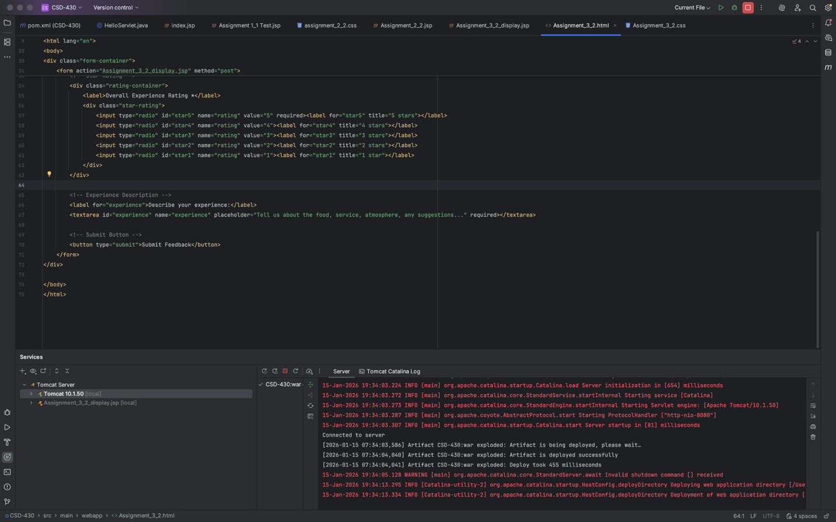

Screenshot of Data Entry HTML Page Output:
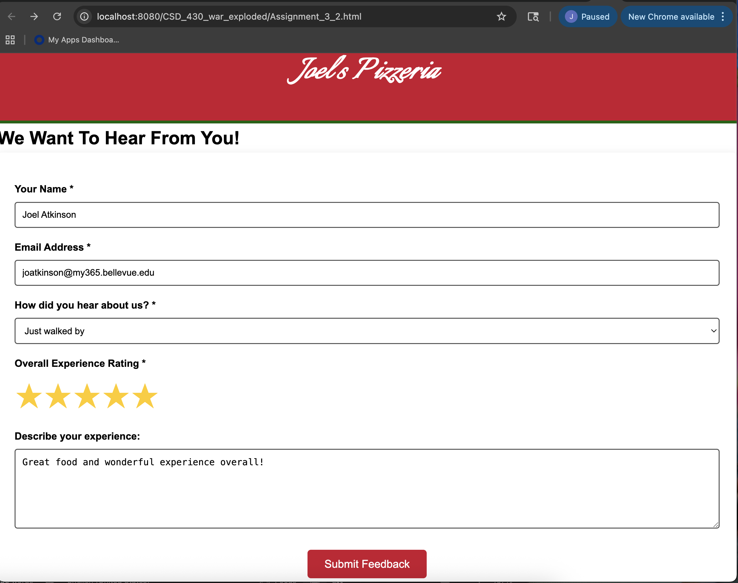

Screenshot of Data Display JSP page output:
